**VISVESVARAYA TECHNOLOGICAL UNIVERSITY**

**“Jnana Sangama”, BELAGAVI — 590018**



**A MINI PROJECT REPORT**

**ON**

**“CRUISE MANAGEMENT SYSTEM”**

Submitted in partial fulfilment of requirements for the course **DBMS Laboratory**

**with Mini Project [18CSL58]** of Fifth Semester BACHELOR OF

ENGINEERING in INFORMATION SCIENCE AND ENGINEERING during the

academic year 2021-2022.



Submitted by

**JANAVHI.S 4MH19IS033**

**MANASA.R 4MH19IS043**

2021 – 2022.

**DEPARTMENT OF INFORMATION SCIENCE & ENGINEERING**

**MAHARAJA INSTITUTE OF TECHNOLOGY MYSORE**

**Belawadi, S.R. Patna (T), Mandya (D) — 571477.**

**MAHARAJA INSTITUTE OF TECHNOLOGY MYSORE.**

**Belawadi, S.R. Patna (T), Mandya (D) — 571477.**



**CERTIFICATE**

This is to certify that the mini project work entitled **“CRUISE MANAGEMENT SYSTEM”** is a bonafide work carried out by **JANAVHI.S [4MH19IS033] and MANASA.R [4MH19IS043],** in partial fulfillment for the **DBMS Laboratory with Mini Project (18CSL58)** prescribed by the Visvesvaraya Technological University, Belagavi during the year 2021-2022 for the fifth semester B.E in Information Science and Engineering. The mini project report has been approved as it satisfies the academic requirements.

……………………… ………………………

Signature of guide Signature of HOD

**(Dr. Sharath Kumar Y.H) (Dr. Sharath Kumar.Y.H)**

Prof, Dept. of ISE Prof, Dept. of ISE,

MIT MYSORE. MIT MYSORE.

|  |  |
| --- | --- |
| Name of the Examiners | Signature with date |
| 1. ……………………… 2. ……………………… | ……………………………………………………  …………………………………………………… |

**ACKNOWLEDGEMENT**

We sincerely owe our gratitude to all the persons who helped and guided us in completing this mini project work.

We are thankful to **Dr. B.G. Naresh Kumar, Principal, Maharaja Institute of Technology Mysore,** for having supported us in our academic endeavors.

We are extremely thankful to **Dr. Sharath Kumar Y. H, Professor and Head, Department of Information Science and Engineering,** for his valuable support and timely inquiries into the progress of the work.

We are greatly indebted to our **guide Dr. Sharath Kumar Y. H, Professor and Head, Department of Information Science and Engineering**, for the consistent co-operation and support.

We are obliged to all **teaching and non-teaching staff members,** of **Department of Information Science and Engineering,** for the valuable information provided by them in their respective field’s. We are grateful for their co-operation during the period of our mini project.

**JANAVHI.S(4MH19IS033)**

**MANASA.R(4MH19IS043)**

**ABSTRACT**

The overall aim of Cruise Management System is to automate the existing manual system by the help of computerized equipment and fully-fledged computer software, fulfilling their requirements, so that their valuable data/information can be stored for a longer period with easy accessing and manipulation of the same. The required software and hardware are easily available and easy to work with.

Cruise Management System, as described above, can lead to error free, secure, reliable & fast management system. It can assist the user to concentrate on their other activities rather to concentrate on the record keeping. The admin can maintain computerized records without redundant entries. That means that one need not be distracted by information that is not relevant, while being able to reach the information.

The main objective of the project is to provide a database that can be very beneficial for a administrator who maintains the cruise database. The admin needs to keep track of all the details of the cruise, passenger details, employee details. The system updates the salary of the employee based on their ssn and add the employee details. It also provides the provision to delete the booking of the cruise.In the project, we intend to use the concepts involved in handling the data acquired using MySQL and PHP. The database will include multiple tables which will be managed efficiently.**TABLE OF CONTENT**

**1: INTRODUCTION**

1.1 AIMOF PROJECT ………………………………………………………... 1

1.2OVERVIEW ……………………………………………………………….. 1

1.3OUTCOME OF PROJECT ………………………………………………… 1

**2: SOFTWARE REQUIREMENTS**

2.1SOFTWARE USED ………………………………………………………... 2

2.2SOFTWARE DESCRIPTION ……………………………………………… 2

**3: SOFTWARE DESIGN**

3.1USER-CASE DIAGRAM …………………………………………………... 3

3.2 ER DIAGRAM ……………………………………………………………… 4

3.3 TABLES …………………………………………………………………….. 5

3.4 SCHEMA DIAGRAM ………………………………………………………. 6

**4: IMPLEMENTATION**

4.1 NORMALISATION ………………………………………………………….. 7

4.2 TABLE DESCRIPTION ……………………………………………………… 8

4.3 TRIGGER ……………………………………………………………………… 9

4.4 PROCEDURE ………………………………………………………………… 10

4.5 ASSERTION …………………………………………………………………. 11

**5: RESULT ANALYSIS**

5.1TEST CASES ………………………………………………………………… 12

5.2 SNAP SHOTS …………………………………………………………………. 12

**6: CONCLUSION AND FUTURE WORK**

6.1 CONCLUSION ………………………………………………………………… 17

6.2 FUTURE WORK ……………………………………………………………….. 17

**7: REFERENCES** ……………………………………………………………………... 18

**1. INTRODUCTION**

* 1. Aim of the project

Cruise management system is a project which aims in developing a computerized system to maintain the booking. This project has main feature where admin login through which the admin can monitor the whole system .It also maintains the employee details who work in particular cruise, his salary and other details.

He can also update the employees salary. Passenger details of who have travelled in which cruise details are available. If a passenger is willing to delete his booking, can delete his booking by just giving his booking ID. Passenger details can be fetched by entering their passenger ID. The port and cruise details are also available. Aim of this project is being developed to help the administrator to maintain the record of passenger, employees and other stuff related to cruise company in the best way possible and also reduce the human efforts.

1.2 Overview

Cruise travel management completely deals with administrator how the booking of tickets have been done.

Cruises are designed for the purpose of providing passengers with a holiday including accommodation and entertainment prioritising onboard amenities and comfort.

Cruise travel management system primarily deals with management of cruise port and passengers.

The system provides broad overview of underlying operational factors that influence the cruise port management.

Every ship is uniquely identified by a cruise ID.

The day on which he books ticket is a booking date every cruise port has employees working for it.

Updation of Employee salary and age.

1.3. Outcome of the project

* Retriving the cruise and port entire details of the company
* Providing the employee details and update the salary, age.
* Providing the booking interface to the administration from the user.

**2. SOFTWARE REQUIREMENT**

* 1. Software used

Operating system : Windows 11

Languages (Front end) : HTML, CSS, Javascript

PHP and Bootstrap 4­

(Back end) : SQL

IDE : Submlime, Xampp and MySQL

2.2 Software description

1.HTML, CSS, bootstrap, javascript – These are the front end languages used for the user interface.

2.PHP - It is the backend language used to interact with Database and front end.

3.MYSQL– It is the database language used in the project. It is used to create a database, table, insert, update, view, delete etc., It acts as the main.

4.Server: XAMPP

XAMPP is a free and open-source cross-platform web server solution stack package developed by Apache Friends, consisting mainly of the Apache HTTP Server, MariaDB database, and interpreters for scripts written in the PHP and Perl programming languages.

XAMPP helps a local host or server to test its website and clients via computers and laptops before releasing it to the main server. It is a platform that furnishes a suitable environment to test and verify the working of projects based on Apache, Perl, MySQL database, and PHP through the system of the host itself.

**3. SOFTWARE DESIGN**

3.1 User-Case Diagram

CRUISE MANAGEMENT SYSTEM

USER

ADMIN

­

employee

3.2 E.R.DIAGRAM

LOCATION

CRUISE

PORT

M N

M 1

BOOK_BY

has

M M

EMPLOYEE

PASSENGER

3.2.1 E.R.MAPPING

* + - Step 1: Mapping of regular entity type.
    - Step 2: Mapping of weak entity type.
    - Step 3: Mapping of 1 is to 1 relationship types. There is no 1 is to 1 relationship types in the ER Diagram.
    - Step 4: Mapping of 1 is to N relationship types.
    - Step 5: Mapping of M is to N relationship types.
    - Step 6: Mapping of multivalued attributes.
    - Step 7: Mapping of N-array Relationship types.

|  |  |
| --- | --- |
| Port_id | Port_name |

3.3 Tables

port

cruise

|  |  |  |
| --- | --- | --- |
| cid | Cruise_name | Cruise_type |

location

|  |  |  |
| --- | --- | --- |
| cid | Port_id | city |

|  |  |  |  |  |  |  |  |
| --- | --- | --- | --- | --- | --- | --- | --- |
| ssn | emp_name | emp_age | Post_name | jdate | cid | email | sal |

employee

|  |  |  |  |  |
| --- | --- | --- | --- | --- |
| psgr_id | psgr_name | psgr_age | amt | psgr_email |

passenger

|  |  |  |  |
| --- | --- | --- | --- |
| Book_id | psgr_id | cid | trdate |

Book_by

3.4 Schema Diagram

Port

|  |  |
| --- | --- |
| port_id | Port_name |

cruise

|  |  |  |
| --- | --- | --- |
| cid | Cruise_name | Cruise_type |

location

|  |  |  |
| --- | --- | --- |
| cid | Port_id | city |

|  |  |  |  |  |  |  |  |
| --- | --- | --- | --- | --- | --- | --- | --- |
| ssn | emp_name | emp_age | Post_name | jdate | cid | email | sal |

employee

|  |  |  |  |  |
| --- | --- | --- | --- | --- |
| psgr_id | psgr_name | psgr_age | amt | psgr_email |

passenger

bookby

|  |  |  |  |
| --- | --- | --- | --- |
| Book_id | psgr_id | cid | trdate |

**4. IMPLEMENTATIONS**

4.1 Normalisation

1NF: In the above table there are no multi valued attributes. Thus, the functional dependency FDI and relation satisfies 1NF

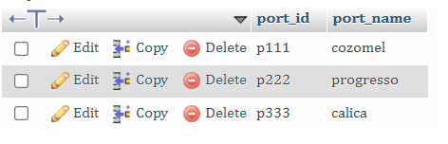Ex:

2NF: There are no partial dependencies found in the above defined functional dependencies. Thus, we can say that relation satisfies 2NF.

This is an example:

|  |  |  |
| --- | --- | --- |
| ssn | emp_name | cid |

employee

3NF: There are no transitive dependencies

found in the above defined functional dependencies. Thus, we can say that relation satisfies 3NF.

Example:

|  |  |  |
| --- | --- | --- |
| ssn | emp_name | cid |

employee

4.2 Table Description

4.2.1 Port table

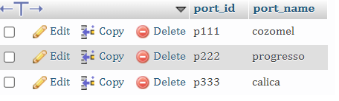

Fig.no 4.2.1

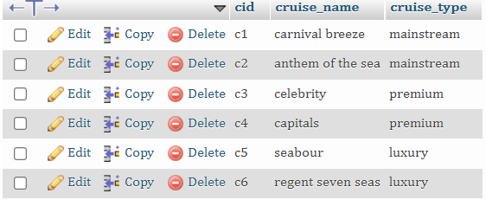4.2.2 Cruise table

Fig.no 4.2.2

4.2.3 Location

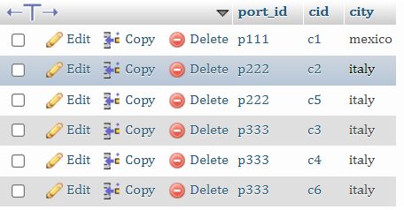

Fig.no 4.2.3

4.2.4 Employee table



Fig.no 4.2.4

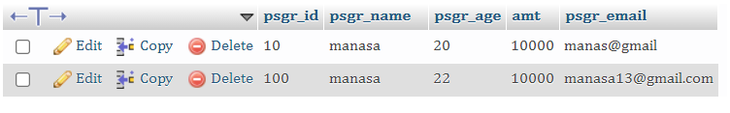4.2.5 Passenger table

Fig.no 4.2.5

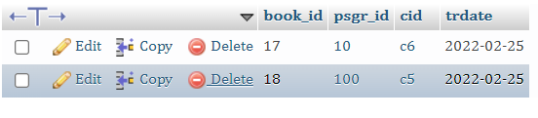4.2.6 Book_by table

Fig.no 4.2.1

4.3 Assertion

An assertion is a piece of SQL which makes sure a condition is satisfied, else or it stops the action being taken on a database. An assertion is a constraint that might be dependent upon multiple rows of multiple tables. Domain constraints, functional dependency and referential integrity are special forms of assertion are dependent (involve) on single row of a table at a time. Any modification to a database is allowed only if it would not cause any assertion are checked only when UPDATE or INSERT actions are performed against the table.

4.4 Triggers

Triggers are stored programs, which are automatically executed or fired when some events occur. Triggers are, in fact, written to be executed in response to any of the following events.

*Code is as follows:*

CREATE TRIGGER `nameCheck` AFTER INSERT ON `employee` FOR EACH ROW if(NEW.emp_fname = NEW.emp_lname) THEN SIGNAL SQLSTATE '45000' SET MESSAGE_TEXT = "first name and last name equal is not alowed"; END IF;

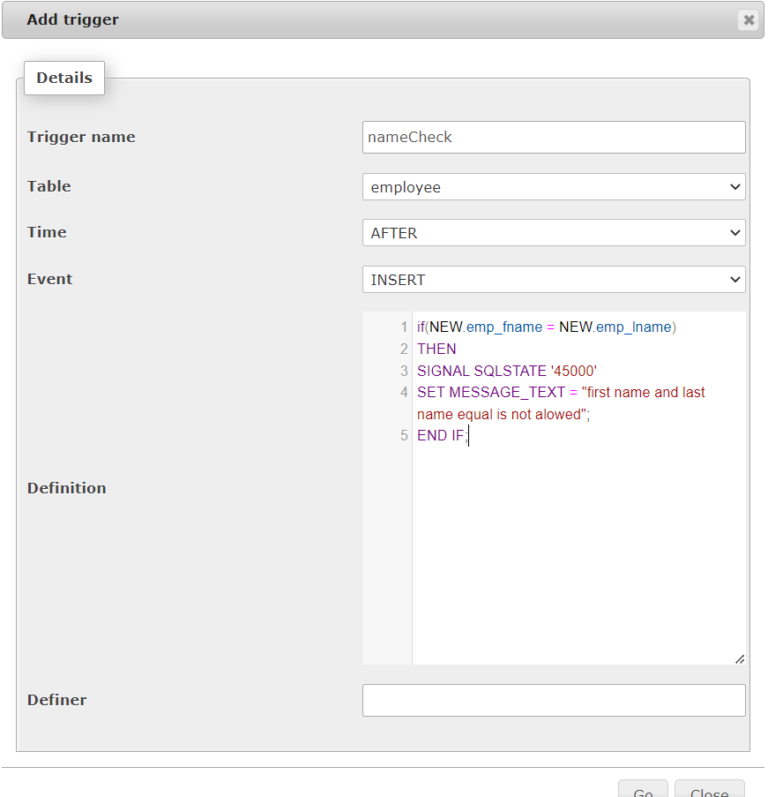

Fig.4.4

4.5 Procedure

A procedure (often called a stored procedure) is a subroutine like a subprogram in a regular computing language, stored in database. There are many useful applications of SQL procedures within a database or database application architecture. SQL procedures can be used to create simple scripts for quickly querying transforming, updating data, generating basic reports, improve application performance, modularizing applications, and improve overall database design, and database security.

Procedure is used to update the employee’s salary and age for a particular ssn provides.

*Code for the stored procedure is*:

DELIMITER $

CREATE PROCEDURE updateEmp(upssn varchar(7), upssn int(8), upage int(4))

BEGIN

UPDATE employee

SET emp_age = upsal , sal = upage

WHERE ssn = upssn;

END;

*Code to execute a stored procedure*:

CALL updateEmp(upssn, upssn, upage);

Snap sort of procedure;

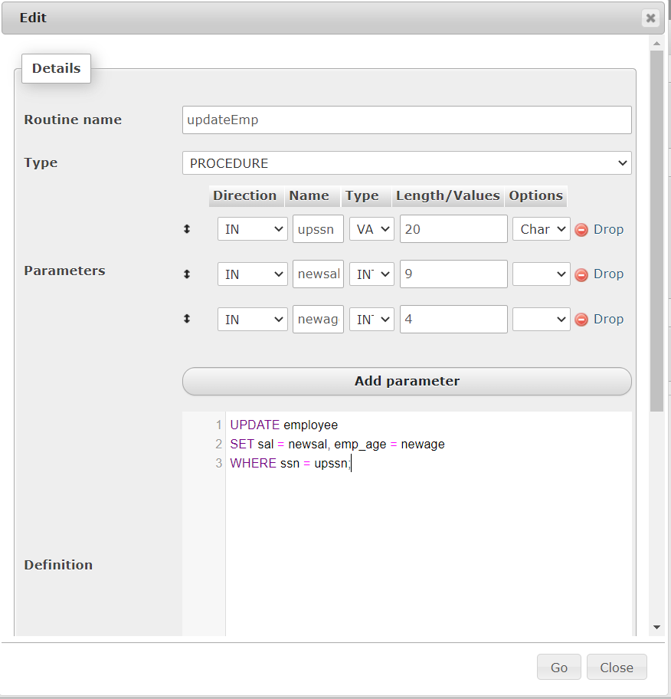

Fig.no 4.5

4.5 Assertion

An assertion is a piece of SQL which makes sure a condition is satisfied, else or it stops the action being taken on a database. An assertion is a constraint that might be dependent upon multiple rows of multiple tables. Domain constraints, functional dependency and referential integrity are special forms of assertion are dependent (involve) on single row of a table at a Cruise Management System.

Any modification to a database is allowed only if it would not cause any assertion are checked only when UPDATE or INSERT actions are performed against the table.

Create assertion passenger_age

Check (psgr_age must BE ATLEAST 2

(select * from passenger Where pssgr_age <2))

**5. RESULT ANALYSIS**

5.1 Test Cases

|  |  |  |  |  |
| --- | --- | --- | --- | --- |
| Test Case no | Test Cases | Excepted Output | Actual Output | Status |
| 1 | Login with empty fields | Empty field cannot be empty | Empty field cannot be empty | Fail |
| 2 | Login with invalid admin name and invalid password | Password or name is invalid | Password or name is invalid | Fail |
| 3 | During booking the cruise, one cannot book the previous and to-day | Invalid date | Invalid date | Fail |
| 4 | Name cannot be other than string. Ex: name not equal to manasa1501 | Invalid Name | Invalid name | Fail |
| 5 | Age cannot be negative | Invalid age | Invalid age | Fail |

Fig.no 5.1

5.2 Snap shots

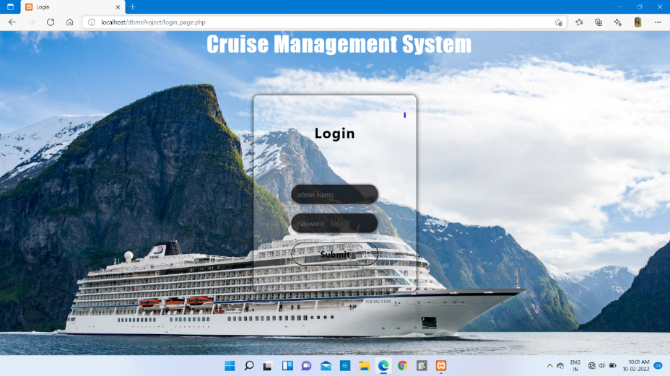 5.2.1 login page : Login page has 3 interface, where it alters for invalid outputs

Fig.no 5.2.1

5.2.2 Home page : displays the nav bar for employee, passenger details and booking page.

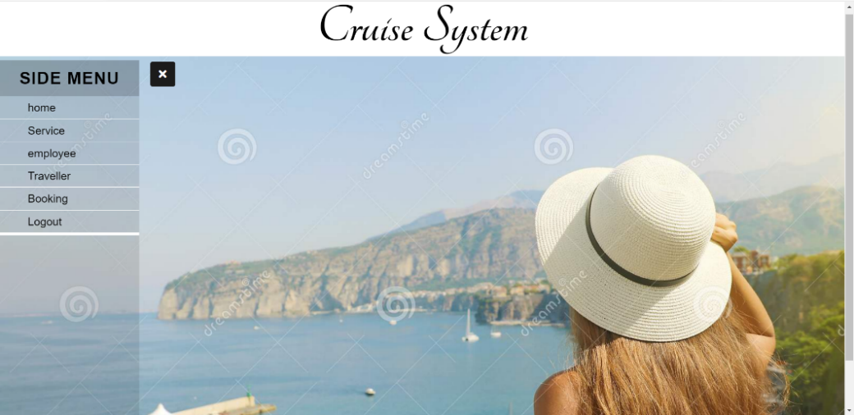

Fig.no 5.2.2

5.2.3 Service page : this page displays the details of port cruise and location. It also contains the information of cruise type and cruise name.

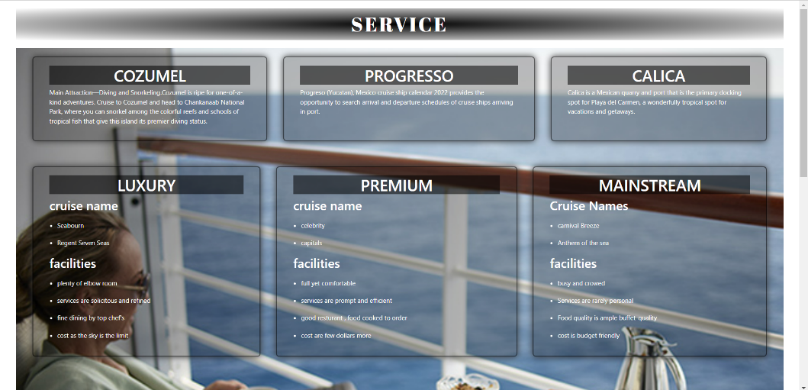

Fig.no 5.2.3.a

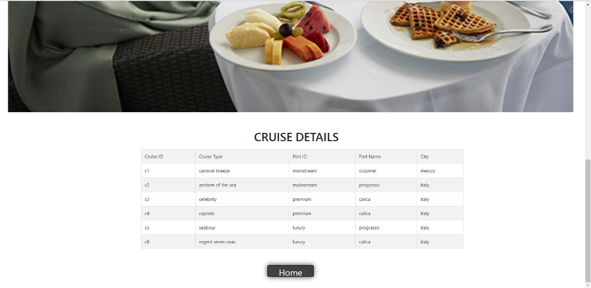

Fig.no 5.2.3.b

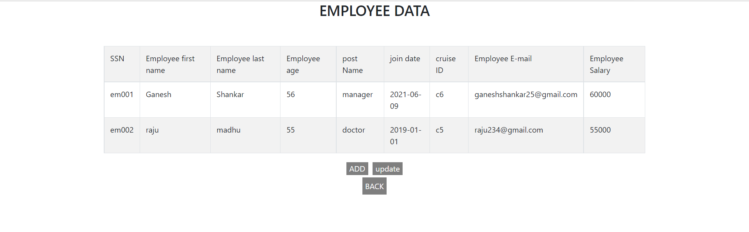5.2.4 Employee page : this page displays the employee details. It also add and update the employee details

Fig.no 5.2.4.a

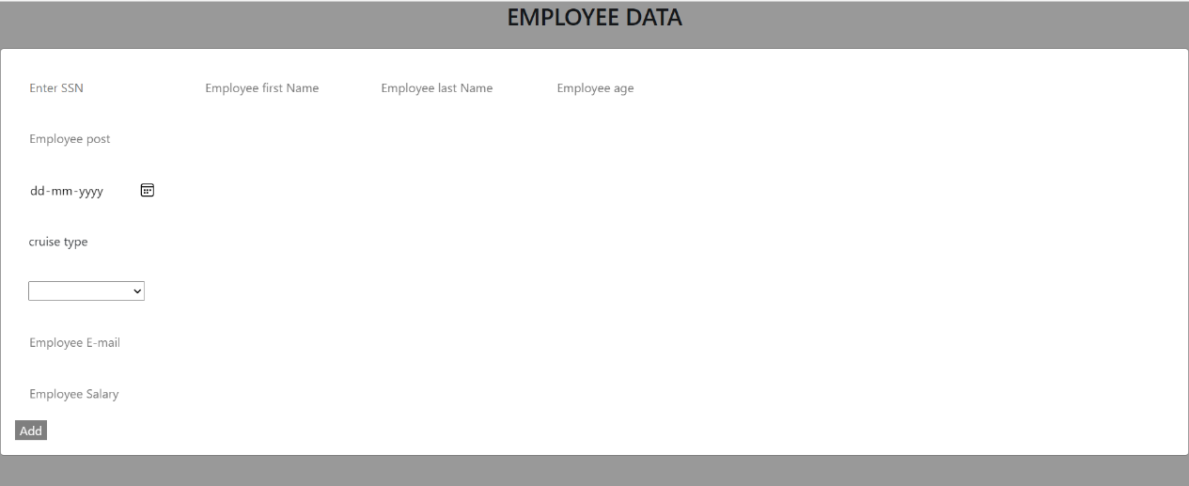

Fig.no 5.2.4.b

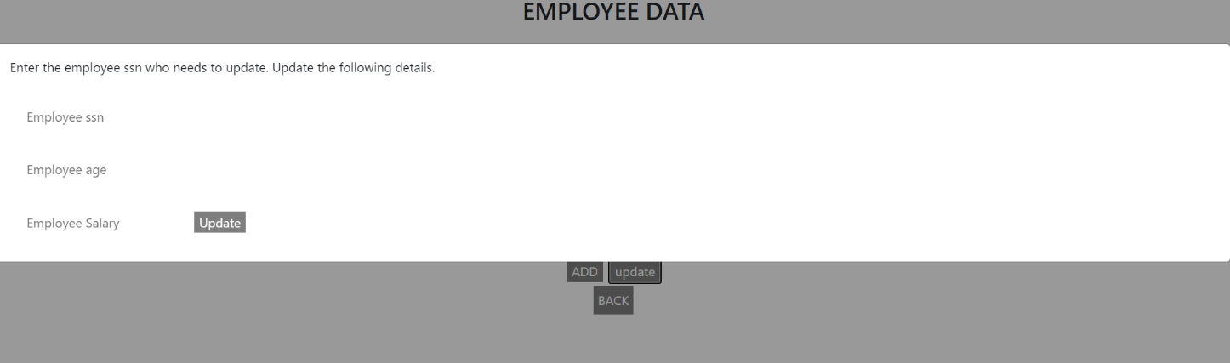

Fig.no 5.2.4.c

5.2.5 Booking page : this page books the cruise for passengers

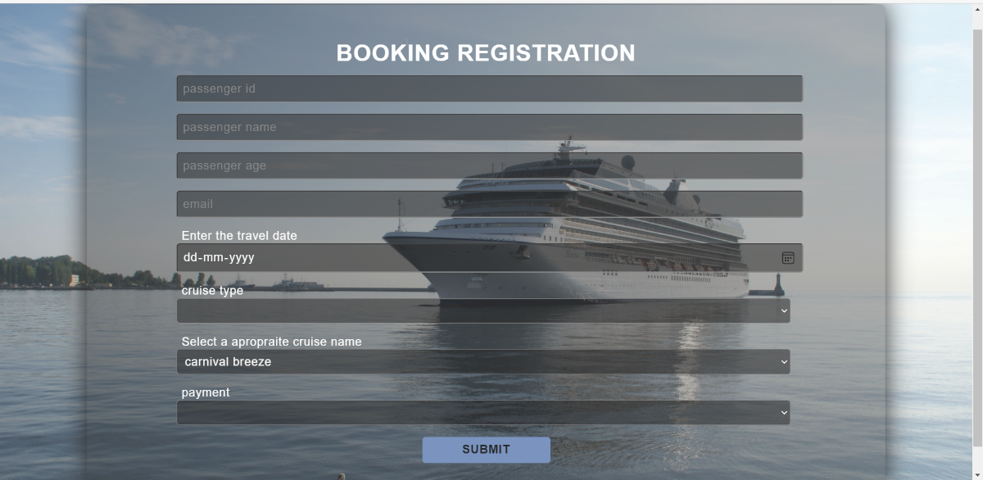

Fig.no 5.2.5.a

5.2.6 passenger page: this displays the passenger details and provides to cancel the booking. It also search the passenger using passenger Id.

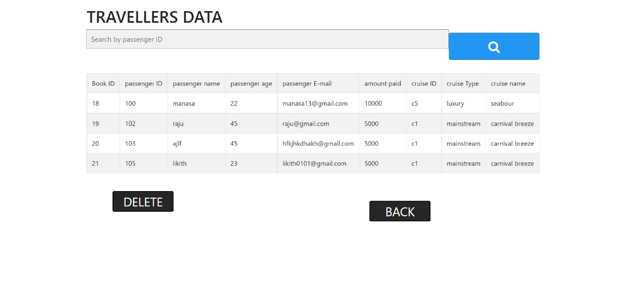

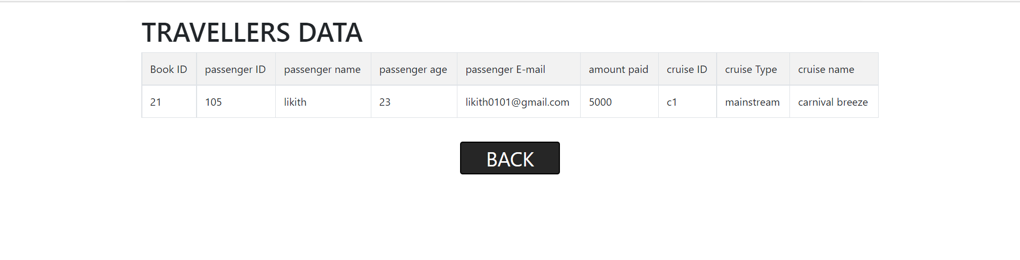Fig.no 5.2.6.a

Fig.no 5.2.6.b

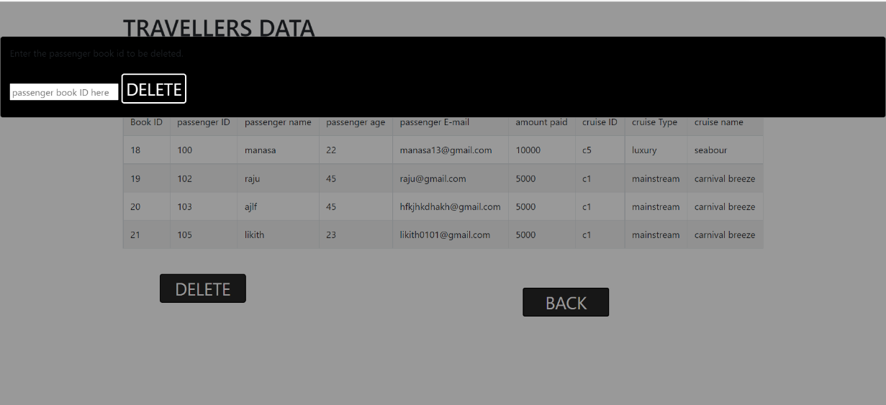

Fig.no 5.2.3.c

**6. CONCLUSION AND FUTURE WORK**

6.1 Conclusion

Admin were facing difficulties while fetching particular the number of passengers travelling in each day. But using this system, admin will be able to keep the track record of the passenger details and employee details where can add, update the employee detail. It also have a good interface to book a ticket.

6.2 Future work

In future days, we thought to improve this project by adding more functionality like online booking where the passengers can also book the cruise.

**7. REFERENCES**

1. HTML Tutorial - <http://www.w3schools.com/html>

2. CSS Tutorial - <https://www.w3schools.com/Css>

3. PHP Tutorial - <https://www.w3schools.com/php>

4. SQL Tutorial - https://www.w3schools.com/sql